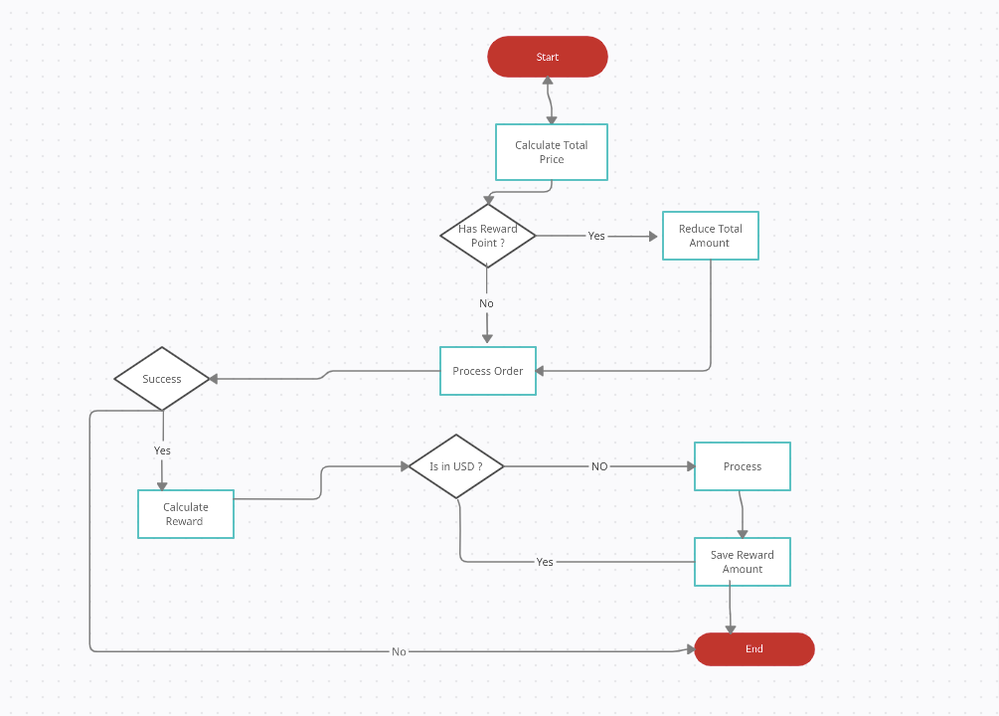Answer of the Question 1.1

Flowchart on the reward system